**Big Data**

pwd

ls

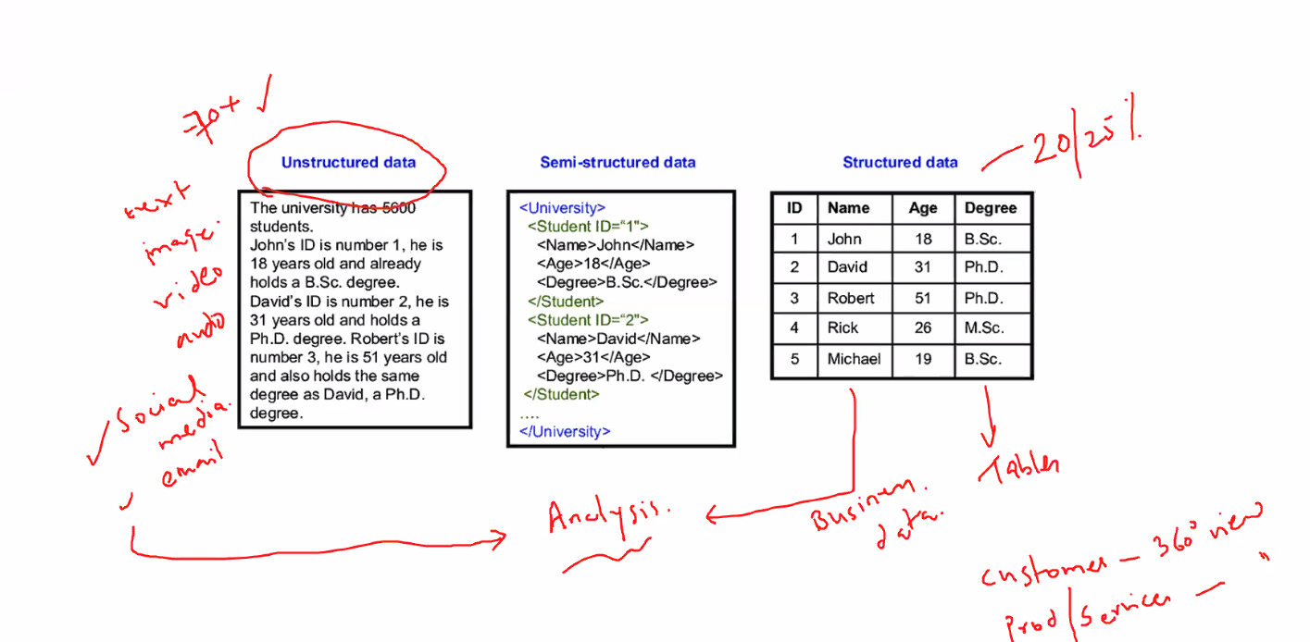

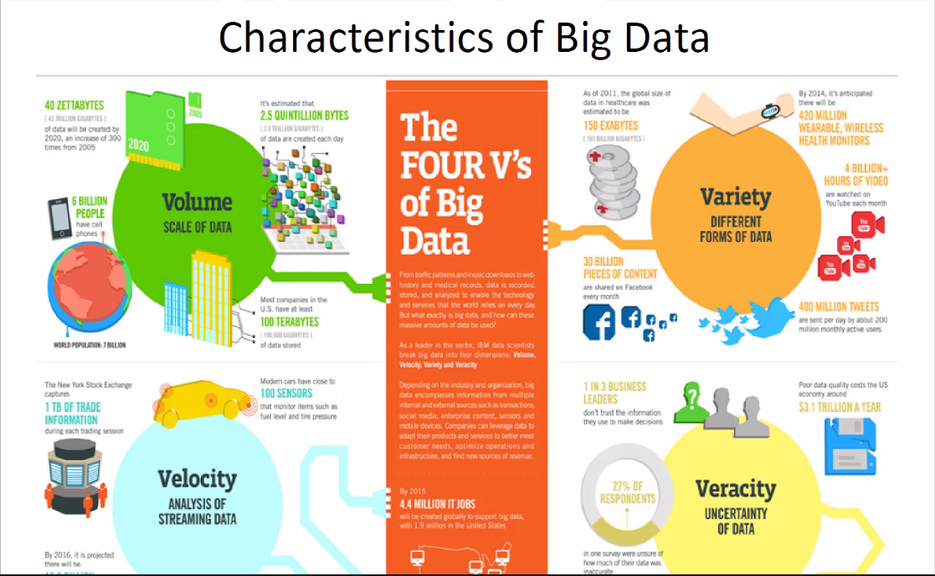

Veracity: Cleansing, preprocessing, validating

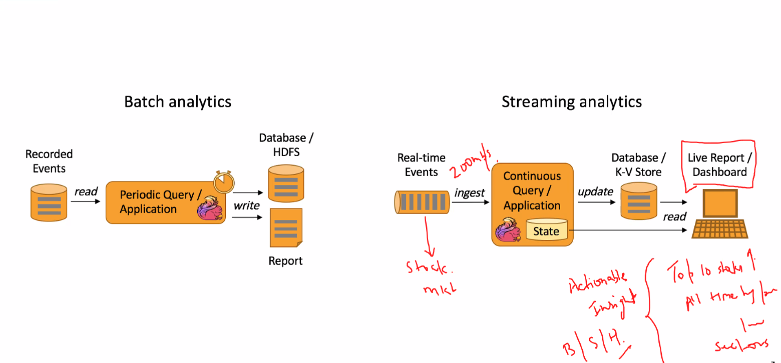

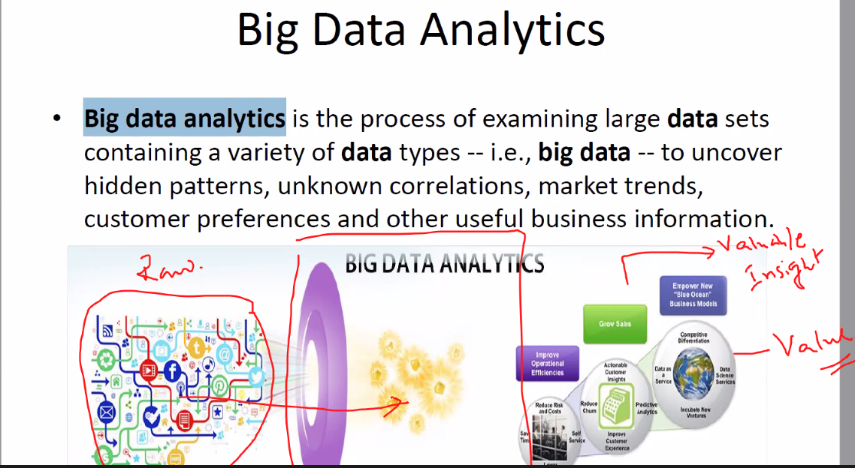

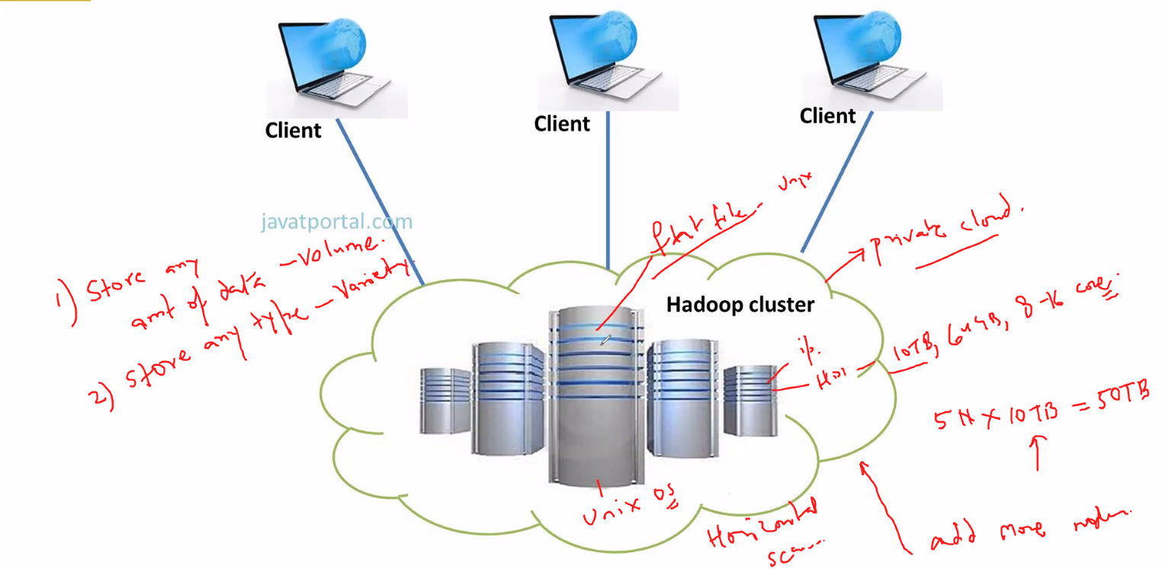

Hadoop -> Transform Unstructured data to structured processed data (processed in distributed storage and parallel computing is used)

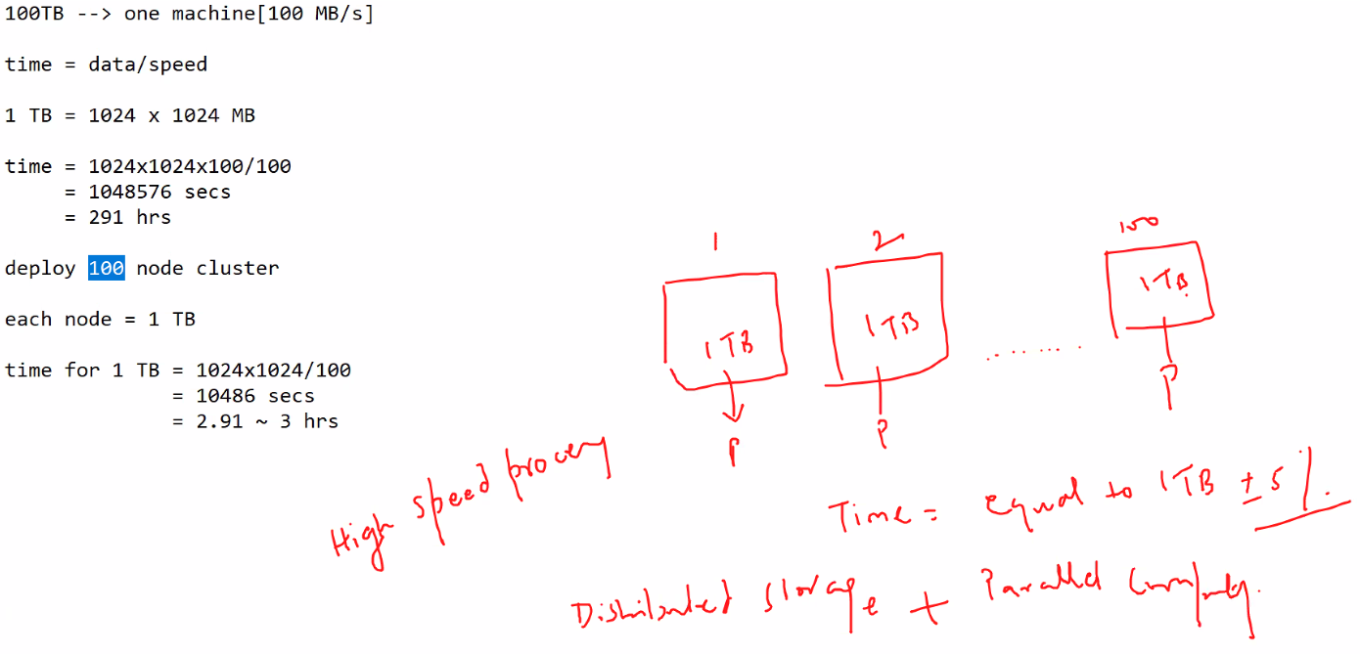

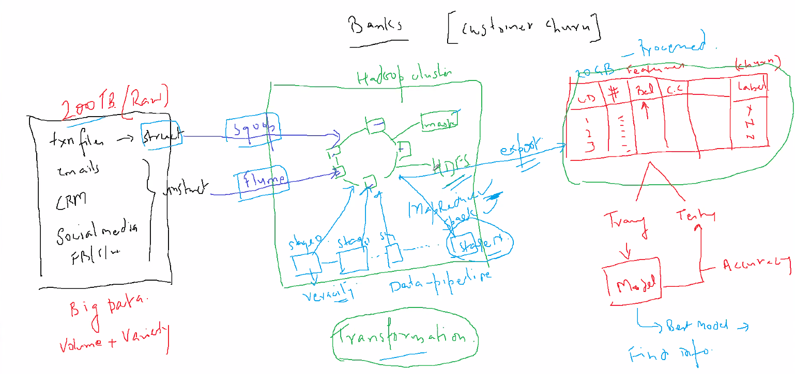

Sqoop => pull structured data faster

Flume => pull unstructured data faster

MapReduce/Spark => Algorithms to process distributed data

Yarn MapReduce written in Java

Hive => SQL query to Java

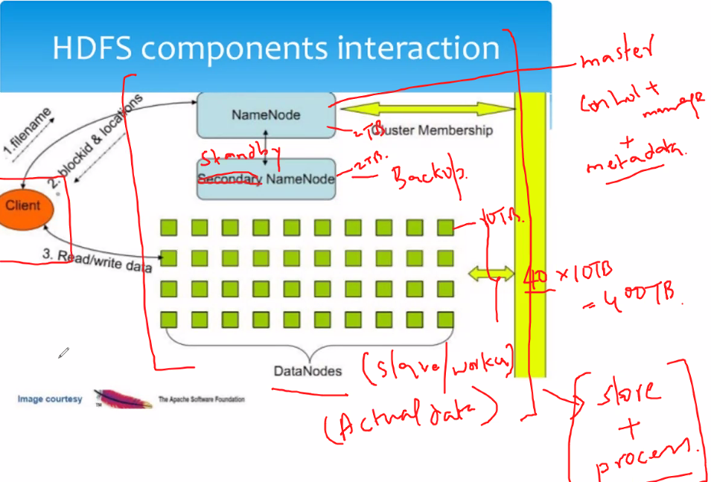

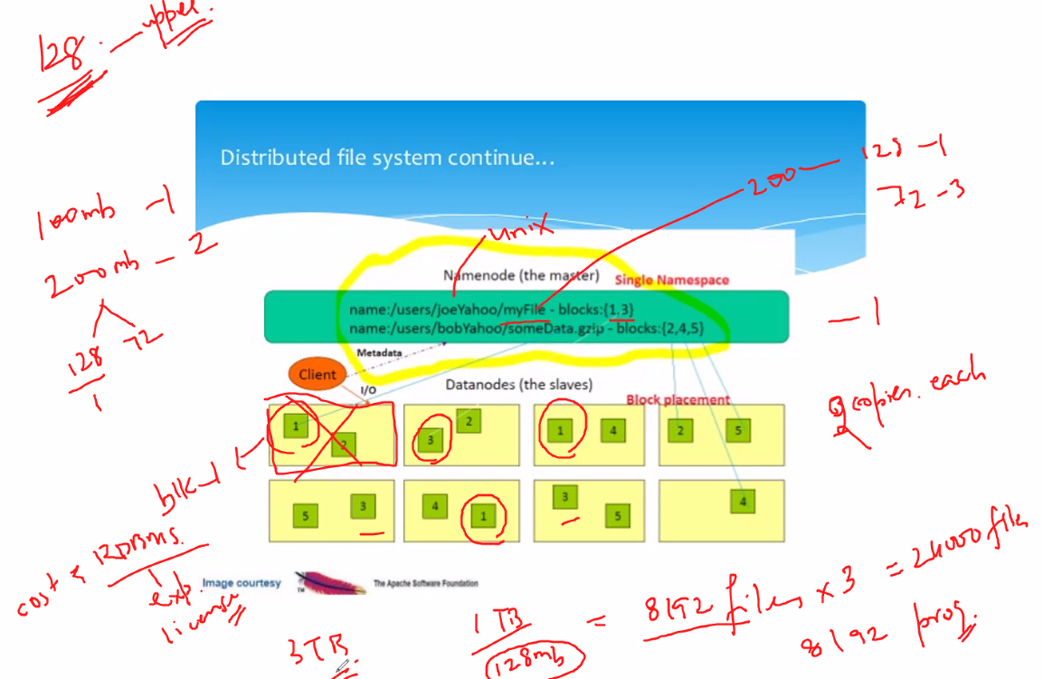

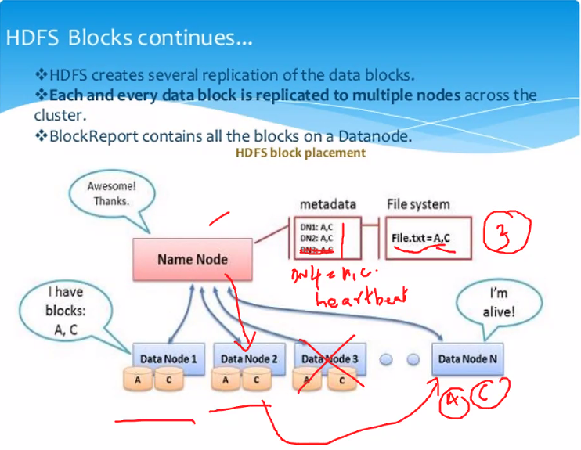

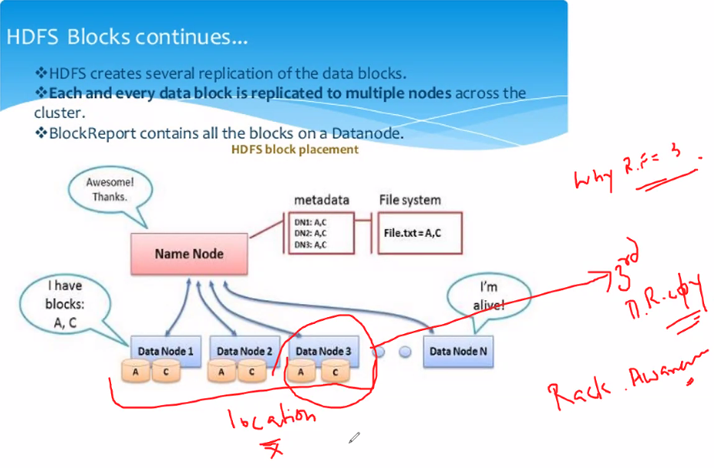

3rd copy => Different rack/location

DR => Disaster recovery

RF => Replication factor

